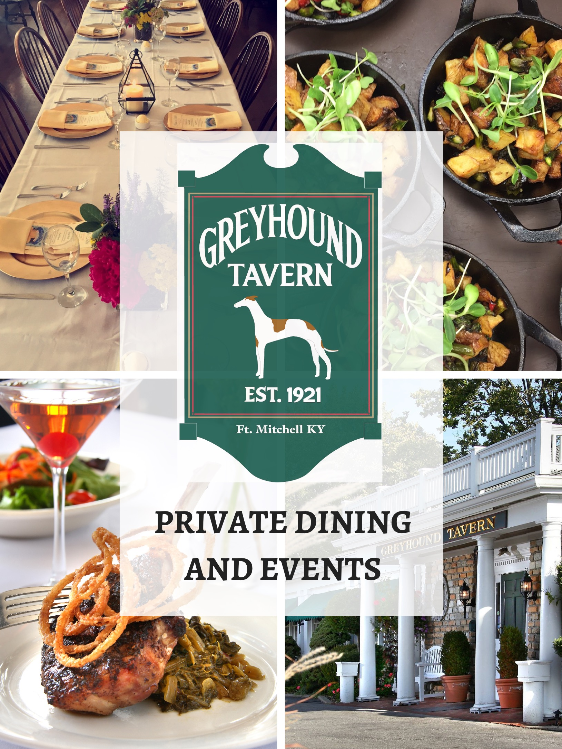
Updated: 03/08/22

General Information

Reservations
Our banquet rooms are available for private functions year-round. Standard reservation times are offered below.
Monday – Saturday Lunch:
11:00-11:30 AM or 1:30 PM or after. (Room reserved for a two-hour time slot.)

Monday – Sunday Dinner:
4:00-5:00 PM or 7:45 or after.
(Room Reserved for a two- and one-half hour time slot.)

Sunday Brunch: 10:00 or 12:30 for the buffet. (Room reserved for a two-hour time slot.)

Sunday Dinner 2:30-5:00 or 7:45. (Room Reserved for a two- and one-half hour time slot.)

There is no charge for the room, but we do require a minimum tab per room. If you will have less than the minimum tab per room the difference will be charged as a “Private Room Fee” to the final bill. This minimum covers the allotted time slot allowed for private rooms. If you need the private room for longer addition charges will apply. (See contract)

Deposit
We require a reservation deposit of $200.00. The reservation deposit will be deducted from the total bill at the time of your party. Deposit is refundable if the cancelation notice is received at least 2 (two) weeks prior to the reservation date.

Menus
To ensure proper service and the highest quality of food, we ask that you choose one of our limited menus (Silver, Gold, or Platinum). Menu details must be finalized one (1) week prior to your reservation.
Beverages
As the host, we will work with you to decide what alcoholic beverage options, if any, you would like to offer.

Children
If children will be present for the event, special menu items are available. $10/child includes their choice of entrée listed below, French fries, apple sauce, and dessert.
- Cheeseburger, Chicken Strips, Grilled Cheese, Fried Cod, Pasta with Marinara.

Can I bring in my own specialty cake?
All of our menu options include in-house baked desserts. You are still welcome to bring in your own dessert and we are happy to cut, plate, and serve for you, however, there is no discount if you elect to bring your own dessert to your function.

Guest Count
A final guarantee guest count is required 72 hours prior to the scheduled event. If no guarantee guest count is given, the client will be billed based on the original estimate, or the actual number of guests, whichever is greater.

Billing and Charges
All balances are due upon completion of your event. Your pre-paid deposit will be deducted from the final bill. We accept all major credit cards, cash, and pre-approved company checks. All items will be presented on one (1) check. Please note that in addition to the listed prices, sales tax of 6% and a gratuity of 20% will be added to your total bill.

All Prices are subject to change.
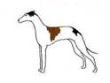

For additional information, please contact
Stefanie Raab
859-331-3767
Sraab@OneHolland.com

Room Information
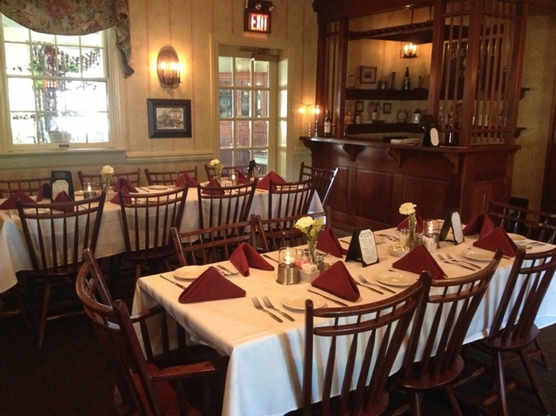
Mitchell Room
Capacity: 50 seated
Enter through French doors into a spacious elegant Mitchell Room. Finished with crown molding, a cozy fireplace, and custom-made wooden pub.
 | MON-THUR | FRI-SAT | SUN
AM | $900 | $900 | $1,100
PM | $1,300 | $1,500 | $1,300

*10% increase to all pricing in December

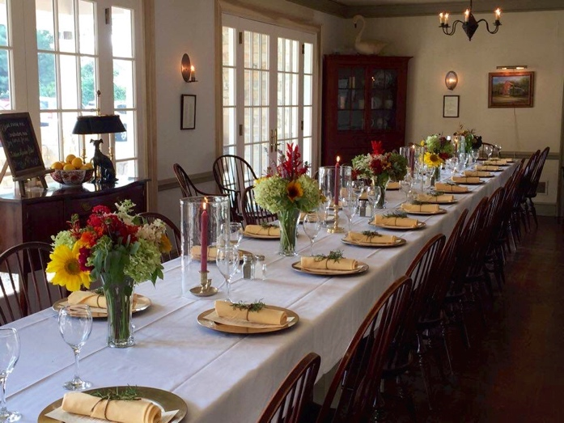
Williamsburg Room
*The Garden Room is accessed through the front of the Williamsburg Room. This room can be seated privately but just a note that there is the possibility of traffic through the very front of this room as guests are seated on our patio.

Capacity: 26 seated

Bright, lively and charming Williamsburg Room. Decorated with restored hardwood floors and three sets of beautiful French doors bring in natural light and elegance for a truly memorable occasion.

 | MON-THUR | FRI-SAT | SUN
AM | $550 | $550 | $650
PM | $750 | $900 | $800
*10% increase to all pricing in December

Hors d’oeuvres
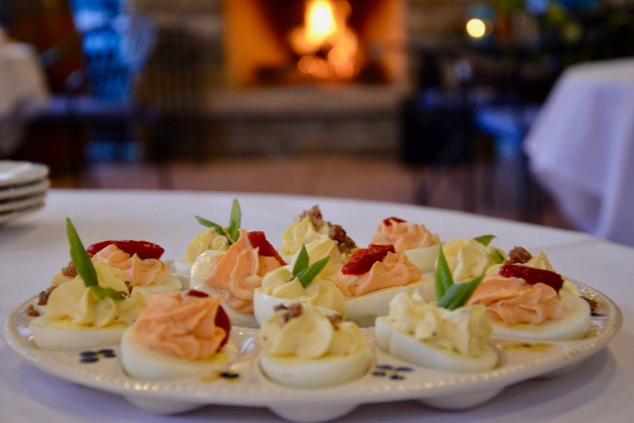
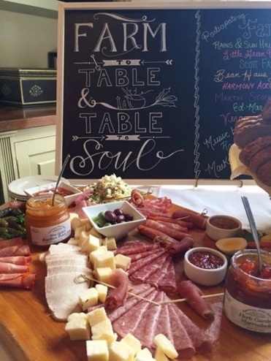
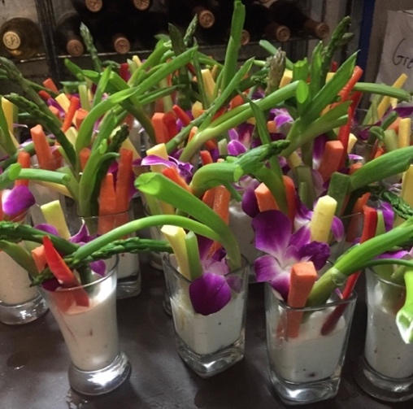
8-10 bites for full meal 5-7 bites before a light meal 3-4 bites before a full dinner
______________________________________________________________________________________

Priced per piece, minimum of 25 pieces.

Chicken & Waffle Bites + Maple Syrup Drizzle $1.75
Fresh Fruit Skewers + yogurt dipping sauce $1.50
Bruschetta + toasted crostini, basil, tomato, mozzarella, balsamic $2.00
Classic Deviled eggs + assorted garnishes $1.00
Cocktail Meatballs + Bourbon BBQ Sauce $1.50
Vegetable crudités (celery, carrots, red pepper, asparagus) + House Dressing $1.50
Bacon Wrapped Sea Scallops $3.25
Hand breaded Chicken Tenders + BBQ dipping sauce $1.50
Country Ham Buttermilk Biscuits + Red Eye Peach Marmalade $2.25
Mini Open-faced Rueben Sandwiches $2.25
Tea Sandwiches (Pimento Cheese, Chicken Salad, Cucumber dill cream cheese) $2.50
Kentucky Hot Brown bites $2.25
Shrimp Cocktail + Cocktail sauce + Lemon $3.00
Mini Crab Cakes (Lump crab meat, house tarter) $3.25
Mini Beef Wellington (Filet in Puff Pastry + Mushroom Duxelle) $3.50
Trays (serve 50)
Chef Fred’s Pimento Cheese + Garlic and cracked pepper warm pita chips $75
Buffalo Chicken Dip $70
Roasted Red Pepper Hummus + assorted crackers $65
Warm Crab and Artichoke Dip + toasted crostini’s $85
Assorted crisp seasonal vegetables with Creamy Cucumber Dip $70
Seasonal Fresh Fruit Tray $65
Raspberry Melba Baked Brie + toasted crostini’s $80
Assorted Cheese Tray + Assorted Crackers + Fruit Garnish $80
The Greyhound Tavern
Limited Dinner Menu Options Page 1 of 2
Coffee / Tea / Soda / Iced Tea Included in Price

SILVER DINNER MENU
$34 PER PERSON

First Course

Garden Salad
Tossed Romaine, Iceberg, and leaf lettuce topped
with sesame sticks and served with
buttermilk ranch dressing.

Entrée

Pork Chop
Grilled center-cut and boneless chop
topped with crispy onion straws.

Fried Chicken
Four pieces of fresh chicken gently rolled in our secret herbed flour and fried just right.

Norwegian Cod
Cold water cod loin, hand breaded and carefully deep fried to a golden brown served with tartar sauce.

Ribeye Steak
A flavorful cut, perfectly seasoned and grilled to a medium temperature,
topped with crispy onion straws.

Accompaniments

Sides are served family style.

Signature Mashed Potatoes
Country Style Green Beans

Dessert
(Select one for the group)

Blackberry Cobbler – Feature Bread Pudding Cheesecake with Raspberry Melba Sauce
Decadent Chocolate Mousse

GOLD DINNER MENU
$38 PER PERSON

First Course

Garden Salad
Tossed Romaine, Iceberg, and leaf lettuce topped
with sesame sticks and served with
buttermilk ranch dressing.

Entrée

Atlantic Salmon
Perfectly seasoned, grilled and
finished with a Tamari brown butter.

Fried Chicken
Four pieces of fresh chicken gently rolled in our secret herbed flour and fried just right.

Double Pork Chop
Grilled center-cut and boneless chops topped with crispy onion straws.

Ribeye Steak
A flavorful cut, perfectly seasoned and grilled to a medium temperature,
topped with crispy onion straws.

Accompaniments
(Select two for the group)
Sides are served family style.

Mashed Potatoes - Country Style Green Beans – Sauteed Fresh Vegetable Medley

Dessert
(Select one for the group)

Blackberry Cobbler – Feature Bread Pudding
Cheesecake with Raspberry Melba
Fresh Strawberry Shortcake
Decadent Chocolate Mousse
The Greyhound Tavern
Limited Dinner Menu Options Page 2 of 2
Coffee / Tea / Soda / Iced Tea Included in Price

PLATINUM DINNER MENU
$45 PER PERSON

First Course

Garden Salad
Tossed Romaine, Iceberg, and leaf lettuce topped
with sesame sticks and served with buttermilk ranch dressing.

Entrée

Filet Mignon
8 ounces of the most tender cut of all steaks.
Grilled to a medium temperature and garnished with crispy onion straws.

Atlantic Salmon
Perfectly seasoned, grilled, and finished with a Tamari brown butter.

Pecan Crusted Chicken
A boneless breast of chicken dusted with a roasted pecan flour.
Served with sweet potato puree and drizzled with our sweet Maker’s Mark caramel sauce.

Grilled Pork Chops
Twin 6-ounce tender Pork Chops grilled and basted with our sweet Kentucky bourbon glaze
and topped with crispy onion straws.

Accompaniments
(Select two for the group)
Sides are served family style.

Signature Mashed Potatoes - Country Style Green Beans –
Scalloped Potatoes - Sautéed Fresh Vegetable Medley

Dessert
(Select One for the group)
Warm Blackberry Cobbler – Feature Bread Pudding- Cheesecake with Raspberry Melba
Fresh Strawberry Shortcake-Decadent Chocolate Mousse

The Greyhound Tavern
Limited Lunch Menu Options Page 1 of 1
Coffee / Tea / Soda / Iced Tea Included in Price

SILVER LUNCH MENU
$23 PER PERSON- INCLUDES

Entrée

Spinach Salad
Fresh spinach topped with chopped egg, bacon, mushrooms, and red onion
rings served with warm bacon dressing.

Chicken Salad Croissant
All white meat chicken salad on a buttery croissant served with chips and coleslaw.

Pasta Gabriel
Delicate angel hair pasta tossed in a medley of fresh mushrooms, tomatoes and scallions in a garlic,
olive oil sauce topped with a grilled chicken breast.

Fried Cod
8 oz of Norwegian Cod fried to a golden brown served with sautéed vegetables and mashed potatoes.

Dessert
(Select One)

Warm Blackberry Cobbler – Feature Bread Pudding- Cheesecake with Raspberry Melba
Decadent Chocolate Mousse

GOLD LUNCH MENU -
$ 28 PER PERSON- INCLUDES

Entrée

Salmon Salad
Spring mix topped with strawberries, toasted almons, apples, goat cheese and grilled Atlantic Salmon. Served with a Raspberry Vinaigrette dressing.

Grilled Chop
A grilled chop served with Green Beans
and Mashed Potatoes.

Fried Chicken
Four pieces of fresh chicken gently rolled in our secret herbed flour and fried just right!
Served with Green Beans and Mashed Potatoes.

Pasta Gabriel
Delicate angel hair pasta tossed in a medley of fresh mushrooms, tomatoes and scallions in a garlic, olive oil sauce. Topped with a grilled chicken breast and served with a crisp tossed salad.

Fried Cod
8 oz of Norwegian Cod fried to a golden brown served with sautéed vegetables and mashed potatoes.

Dessert
(Select One)

Warm Blackberry Cobbler – Feature Bread Pudding- Cheesecake with Raspberry Melba Fresh Strawberry Shortcake
Decadent Chocolate Mousse

The Greyhound Tavern

Contract for Private Room

Conditions of Contract

- A deposit of $200.00 (two hundred dollars) is required to reserve the use of our dining room for a private function. This deposit is not a room charge and will be applied to your bill or returned by check to the individual that made the reservation and deposit. Deposits are refundable if the cancellation notice is received at least 2 (two) weeks prior to the reservation date. If a cancellation notice is received less than 2 (two) weeks from the reservation date, the deposit will be non-refundable.

- Any party below the minimum sale requirement will be charged the difference as “Room Rental Fee” to the final bill. All food and beverage sales (not including tax or gratuity) count towards this minimum.

RESERVATION ROOM MINIMUM: $__________________

- Your reservation covers a designated time slot. Additional time must be booked in advance. See pricing below. (Time will not be pro-rated)
Charge per additional hour beyond 2-hour reservation time slot.
Mitchell Room
AM | $200/hour
PM | $300/hour
Williamsburg Room
Garden Room
AM | $150/hour
PM | $250/hour

- A sales tax of 6% and gratuity of 20% will be added to the final total bill. All payment is due at the completion of event.

- Final menu selections are required 1 (one) week prior to the date of the event.

- Final guest count is required 72 hours prior to the scheduled event. If no guarantee guest count is given, you will be billed based on the original estimate, or the actual number of guests, whichever is greater.

- Greyhound management prior to your arrival must approve any party favors, decorations, or props.

- Due to state and local regulations, guests are not permitted to bring their own alcoholic beverages.

- All prices subject to change.

Today’s Date: _____________ Please Circle: Mitchell Room Williamsburg Room

Name/Organization: _______________________________________________________________

Contact Person: ___________________________ Phone Number: ___________________

Address: _________________________________________________________________________

E-mail Address: ___________________________________________________________________

Reservation Date: ________________ Reservation Time: ___________ Total # of Guests: _______

Signature: _______________________________________ Date: ________________________

2500 DIXIE HIGHWAY – FT. MITCHELL, KENTUCKY 41017 (859-331-3767) WWW.GREYHOUNDTAVERN.COM

